

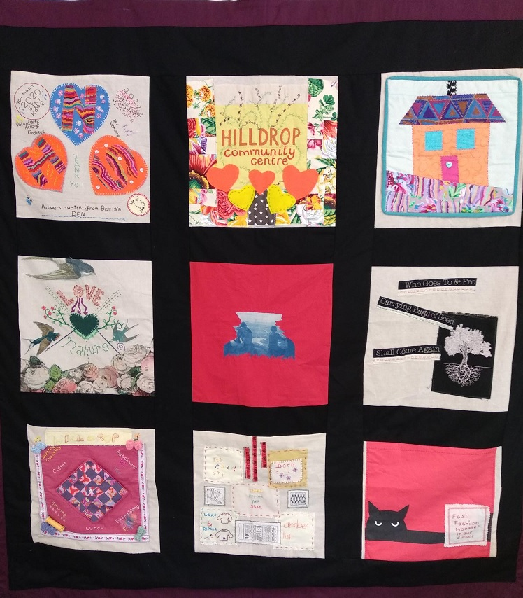
Hilldrop Area Community Association

Annual Report 2023-24

About us
Hilldrop Area Community Association (HACA) is a registered charity that aims to promote opportunities, services and activities that increase the social and economic wellbeing of our diverse community, supporting social cohesion and benefitting all.
Located in the Tufnell Park (formerly St George’s) Ward of Islington and based at Hilldrop Community Centre, we are an established multi-purpose community venue, offering a wide programme of activities and services that respond to local interests and needs. We are committed to involving the community in the shaping of our programmes, and work in partnership with a vibrant network of local groups, providers, and statutory services.
Our Association was first formed in 1986 in the wake of rising community turmoil. Local tenants of the surrounding Hilldrop Housing Estate brought together different groups and individuals who took over the management of an estate building that became Hilldrop Community Centre. The first Head of Centre was Bob Drinkwater, whose dedication and commitment saw him hold the post until March 2016 - an amazing 30 years.
Our current Head of Centre, Elaine Maffrett, joined us in September 2018, and since then HACA has continued to deliver on its aims and consolidate its practice, bringing in new activities and developing the Play Project After School Club and Holiday Playscheme services. The strong community base on which we were founded has continued to this day, with many staff, volunteers and trustees all local to the area.
We are committed to:

1. Providing strategic leadership within the local community.
2. Coordinating a coherent and engaging neighbourhood-based offer of services and activities for local residents.
3. Ensuring that local community facilities and assets are utilised to their full potential.
4. Attracting external funding to facilitate the delivery of activities and services specific the local community’s needs.

A message from our Head of Centre
The past year has seen major refurbishments taking place in the centre, largely due to our successful applications to the Thriving Communities Fund. Our Main Hall, originally built as a pub, has new windows and doors, and a fire shutter installed, all creating a safer, warmer and cleaner environment for all that use it. A new colour scheme has brightened it up and we feel confident in promoting these spaces for affordable hire and improving use by our regular community group.

In addition, we have had the paving and road resurfaced around the centre. It has made the centre more accessible to those with mobility issues and created a lovely backdrop to all the planting and growing activities we have.

A special feature of Hilldrop Community Centre is that it is off-road and located in a ‘green corridor’ right in the middle of the Hilldrop Estate, and in a densely populated urban landscape. Our gardens and communal spaces provide a valuable natural environment for residents and centre visitors to enjoy - as well as a haven for local wildlife. We have continued our work to maximise the benefits of these spaces.

An important part of our work is to support residents to facilitate and formalise their own community groups and interests. This year we were joined by The Tarbiya Club, a group of home schoolers who provide a weekly educational and physical session for their members, and The Eritrean Family Support Group who meet weekly to provide support and social activities.

As always none of our successes and achievements would be possible without the hard work and continued support of our Staff, Trustees, volunteers, donors, residents, and members. All have played an essential part in the successes and achievements of the centre over the past year.

A special mention goes to The Kingsley Organisation who we said goodbye to in November 2023. This lively disability support group has been based at the centre since 2019. Their fun sessions and good humour will be very missed

2024 also saw our Stay and Play come to an end, which has been delivered at Hilldrop for over 25 years. It started when there was little support or activities for families of under-fives, but since then, first through SureStart, and now with Bright Start continuing this valuable much needed work, we found that we were duplicating statutory services, and we need to be mindful of ensuring that we use our dwindling funds to fill gaps not already provided for. It was a difficult decision to close this service and say goodbye to Arifa Choudhury and Nasrina Ahad. We wish them all the best for the future!

Elaine Maffrett – Head of Centre

A message from our Chair of Trustees

I’m pleased to report that Hilldrop continues to flourish with our Play Projects, Food Hub and a host of other regular community groups, continuing to provide valuable support to the local community.

Key to this success has been the Hilldrop staff, both permanent and part time. Elaine Maffrett, Head of Centre, has provided strong leadership, along with Play Project Manager, Iola Isaac and, until recently, Centre Administrator Natasha Harper. Natasha left us in April 2024 to explore other avenues and while we were sorry to see her go, given her great contribution to the Hilldrop over the past 5 years, we are pleased to welcome Michael Matthews, our new Centre Administrator.

We are also losing another valued colleague, Play Project Deputy Manager Jahanara Rahman, who is leaving the Hilldrop after 8 years.

I would like to place on record our gratitude to both Natasha and Jahanara for all their hard work and dedication during their time at the Hilldrop.

I’d also like to thank everyone who uses the Hilldrop Community Centre and we look forward to doing whatever we can to support the local community over the coming winter months.

Thanks are also due to our ward councillors and Islington Council, who have been unstinting in their support of the Hilldrop and without whose support we couldn’t do what we do.

Finally, I’d like to thank my fellow trustees for all their work and support, in particular our Treasurer, Glyn Clark, and our Bookkeeper, Anita Nightingale, who do so much to ensure the Hilldrop maintains a firm financial footing.

Stephen Moorby – Chair of Trustees

Our Community Space
Our building provides free space for residents’ meetings, ward panels, public consultations, and events. We also offer affordable space to rent for activities, training, private meetings, and small parties, including discounted rates to charities and local interest groups. We welcome those that seek to provide affordable activities that promote health and wellbeing, social activity, and local participation for local residents.

Our relatively small building punches above its weight with a large main hall, a small hall with patio, and a training room and kitchen facilities. Continuing improvements to the building are creating a safe, accessible and practical multi-purpose environment. Situated on ground level, the centre is surrounded by ample pleasant garden space.

Alongside our long-term regular bookings, the centre is very popular with families organising children’s parties at the weekend. Our out-of-hours bookings are attended by our Warden - Celine Nodinot who is on hand to introduce hirers to the centre and provide any assistance during each booking.

Thanks to Celine and our Cleaner - Sandra Florez, who keeps our building in tip-top condition, we can maximise this vital income stream that helps us to fund events, improve facilities, and provide materials and equipment for our own services.

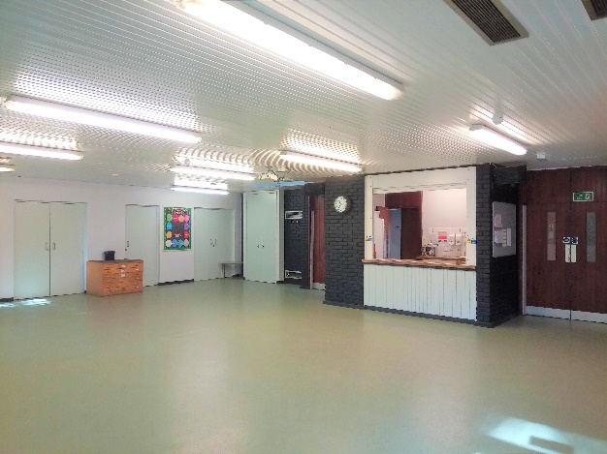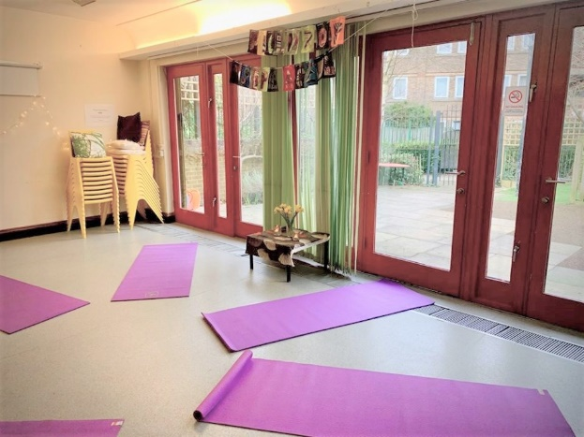

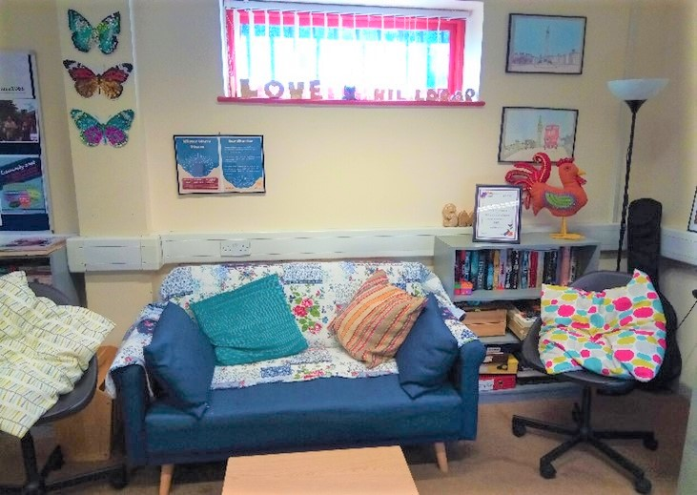
Some of the amazing people and groups that have supported us through 2022


Our partnership continues with IT professionals People’s Place Community Partnerships (PPCP). PPPC provide IT support for several grassroots voluntary organisations and manage the 21st Century Skills (21CS) project, a training and work experience programme supporting young people into IT careers. Since they came on board, we’ve not only had our operations transformed, but we’ve also had the great pleasure to get to know some of PPCP’s young trainees and follow their journeys into new careers.


Tufnell Park Ward Police’s Safer Neighbourhoods Team. The team hold their quarterly Ward Panel meetings at the centre to discuss local concerns and policing strategy. The safety team attend our events where possible and visit our community groups.


Shake-Scene Shakespeare Theatre Company, specialise in improvised ‘cue script’ performances, and for the third year running gave a very special fundraising performance of As You Like It. The performers, including our very own Geraldine Brennan, gave their time and considerable talent for free to help raise funds for our services, and we were delighted to welcome a near full house of guests to the centre on the day. Thanks for raising nearly £300 for our charitable activities - an amazing achievement!



Hilldrop Artistic Take Over and Cut Moose
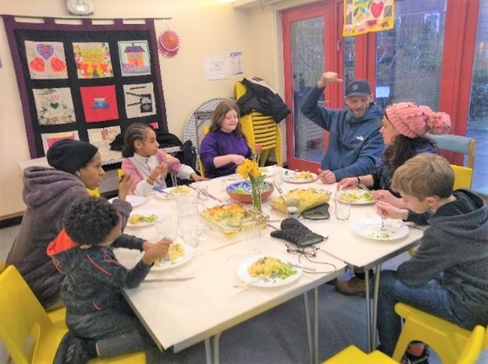
Facilitated by Helen Ainsworth, Creative Dinners provides parents and children with opportunities to prepare a multi-course family meal each week and sit down and eat together as a group. As always with Cut Moose activities, there was an additional creative element with the children being encouraged to have conversations, explore ideas, and create artworks at the table before helping to prepare dinner. Our families all got to know each other and picked up some handy recipes & techniques along the way.

A regular Sewing Course is now offered at the Centre, provided by Adult and Community Learning and their fantastic tutor Coraleen Charles. Our Sew & Craft drop-ins have always been popular, so we felt it was important to provide a dedicated course covering all the basics, and for the advanced

As a community space serving the Hilldrop Estate and surrounding area, we regularly host Tenants and Residents Association meetings, including both the Brecknock, Penderyn Way and Ivinghoe House TRA meetings.

Also, Community Play 4 Holloway, an independent coalition working to ensure the needs of the local community are at the heart of the redevelopment of Holloway Prison.

The Hilldrop Ukulele Band
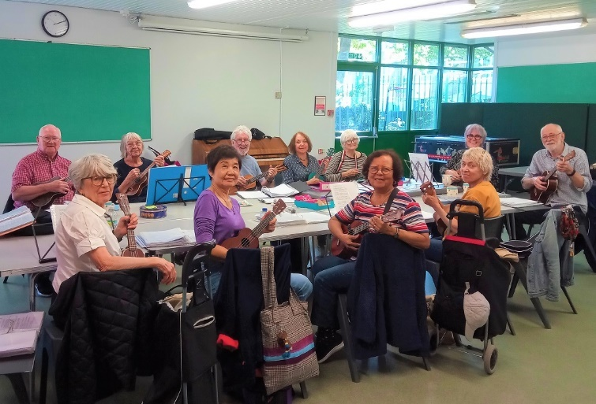
On Friday afternoons Hilldrop is filled with the joyous sound of a Ukulele jam, where anyone with a Uke, voice, or other instrument, is welcome to join in a relaxed singalong covering a wide range of popular and traditional songs.

Over the year the band support us at community events by providing welcome entertainment and creating a wonder atmosphere.

The Food Hub

Our Food Hub services include our weekly Tuesday Lunch Club & Social. We’re also able to distribute donated food to people in need, thanks in a large part to local volunteers Jane & Claire who bring a weekly delivery of surplus food from M&S during term-time.

We’re not a 'food bank' but we do our best to assist local people on request by providing groceries and household essentials when we have them, or signposting to other providers.

Our Food Hub Cook, Robin Campbell, creates impressive dishes each week from surplus donations, assisted by regular volunteers Semhar, Alison and Saada. Saada often makes traditional Eritrean coffee for our Lunch Club guests and has made some incredible dishes such as Doro Wat with Injera (a spiced chicken stew with boiled eggs, with a fermented pancake-like flatbread). During School Holidays Robin cooks for children attending our Holiday Play Scheme.

We’re a hub for St George’s Mutual Aid group, whose volunteers arrange deliveries of hot take-away lunches (provided by Food 4 All) to vulnerable people unable to reach the centre.
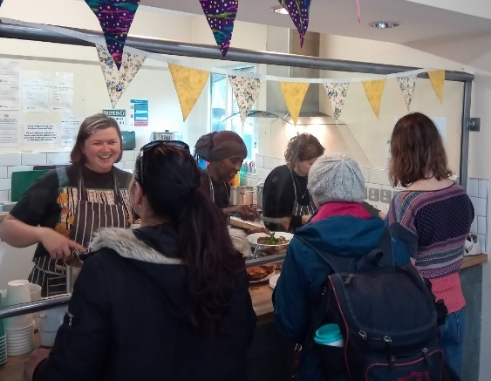
The Tuesday Lunch club is attended by up to 40 people a week, but with a membership of approx. 90 at events like the Christmas lunch this can exceed 100. Our Christmas Appeal helps ensure we meet this demand and also provide Christmas hampers for everyone that attends

The Hilldrop Play Project
Our Play Project service delivers a lively After School Club for 39 weeks of the year and a school Holiday Playscheme which runs for 9 weeks during school holidays. Open to children aged between 4 and 11 years, we provide affordable childcare options with a full range of fun and stimulating activities run by our qualified, friendly, and experienced staff.

Our Play Project is diverse and inclusive. We encourage every individual child to reach their full potential. Activities are child led, allowing for individual independence and expression whilst building numerous skills.
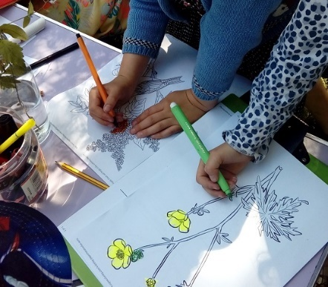
Our After School Club picks up from Tufnell Park and Hungerford primary schools. We are grateful to Islington Council for the grants that enable us to subsidise the fees that parents/carers have to pay; this was greatly enhanced by a restructuring of the fees system in 2023 to include even lower rate for families on low incomes.

Our Holiday Play Scheme is accessible to children from further afield but as its very popular families have to book early to avoid disappointment. Alongside daily indoor activities we often organise field trips to parks, museums, and live events.

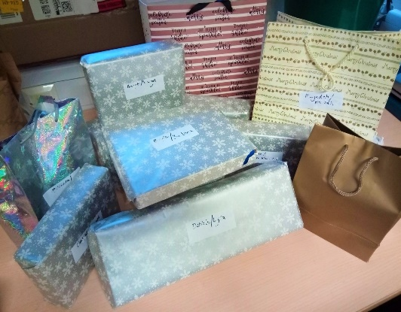

Huge appreciation for our annual delivery of toys from the East London Business Alliance (ELBA).

ELBA’s annual Toy Appeal encourages companies and their employees to buy and donate toys to children’s centres across East London and Islington so that every child can feel included in the joy of opening a Christmas gift.


We’re extremely grateful to have ongoing support from the Gasper the manager and staff at our local Nisa - Brecknock Road, who provide a weekly donation of fruit and everyday groceries to the Play Project so that we can prepare healthy snacks for the children.

In 2023 they nominated us for a Making a Difference Locally award of £1000 and this enabled us to purchase play equipment and fund activities for the Holiday Play Scheme.


Bright Futures Early Help Service
Islington’s Bright Futures service gives one-to-one support and advice to families with children aged 5-19 years. Advice sessions can be booked at Hilldrop on Wednesday afternoons during term-time, and help can be sought for a wide a range of issues ranging from educational, health or behavioural concerns, to managing family conflict.

The Hilldrop Gardening Project - A Year In The Garden
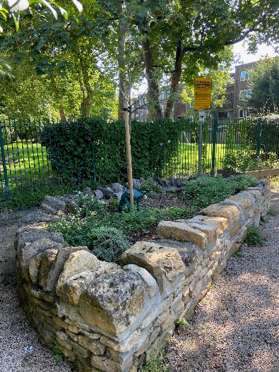
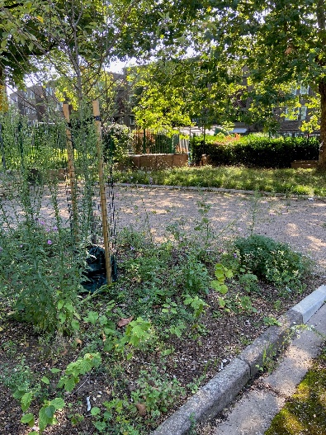
2023-24 was a great year for the Hilldrop Gardening Project. We had already planted our raised beds outside the centre and in Community Lane with vegetables and herbs, broad beans and onions, mint, and coriander, nasturtium and chamomile, lavender, and blackcurrant sage.

We now have fruit trees and edible hedges for birds and insects. In November we planted young trees and shoots and built some compost bins, and by spring we were planting double hedges and a sea of new bulbs. We sowed nasturtium seed saved from the beginning of the year, as well as and crimson clover in the grassy patch for diversity.

In March 2023 there was only one thing missing, and that was a sign to name the new area the Hilldrop Wildlife Garden. Local artist Winston Scotland took up the challenge, creating a beautiful hand-painted triptych adding a splash of vibrant colour to complement the blooming beds.

Our wonderful gardening volunteers have given so much to the project, and I’d like to thank Tom, Yasmin, Karen and Alfred for their hard work throughout the year. I’d also like to thank Elaine for managing the project with such energy and vision, Will and Billy from the Octopus Community Network for their practical support, all our workshop facilitators, and everyone who came along to help us with planting. It’s been an incredible achievement we can all be truly proud of.
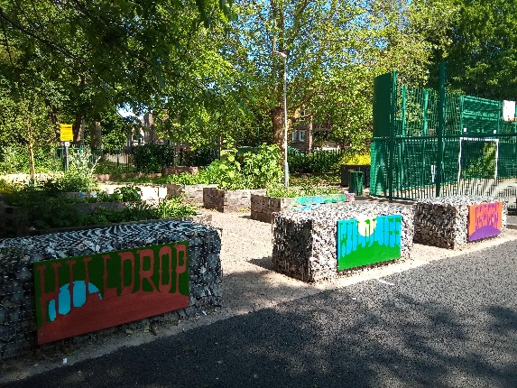
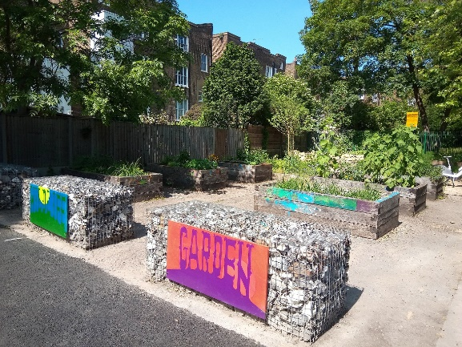

FINANCE

An overview from our Treasurer

I’d like to thank Anita Nightingale, Finance Officer and Elaine Maffrett, Centre Manager for the dedicated and detailed work to ensure our budgets and accruals were completed with thorough accuracy for the financial year 2023/24.

The centre sets an annual budget with a modest net loss, with the expectation that over the course of the year, the small loss will be transformed into a net profit through successful grant applications and strong take-up of the centres services, specifically hall hire and after school clubs. The centre has continued to maintain its target level of cash reserves. This helps to mitigate the risk of any changes of circumstance that may affect the centre’s finances, such as a withdrawal of funding or the ending of a service agreement.
I would like to thank the London Borough of Islington for their financial support through Voluntary & Community Sector funding, dedicated staff at the Council for their assistance, as well as our local Councillors for their ongoing support.

Finally, I’d like to thank Andrews Tete-Donkor from Glandys for preparing our final accounts again with such great efficiency.

A special mention also goes to Natasha Harper, our recently departed Centre Administrator, who behind the scenes has performed many of the duties associated with invoicing and reconciliation of our bank accounts.

Glyn Clark - Treasurer



We would like to take this opportunity to thank the Hilldrop Staff, Volunteers and Trustees who have all contributed to developing the centre and organisation, enabling it to flourish.
Staff Team
Elaine Maffrett – Head of Centre
Iola Isaac – Play Project Manager

Natasha Harper – Centre Administrator Jahanara Rahman – Deputy Play Manager
Anita Nightingale – Finance Officer Mick Carroll – ASC Play Worker
Robin Campbell – Food Hub Coordinator Amy Marciano – ASC Play Worker
Celine Nodinot – Centre Warden Stacy Dugdale – ASC Play Worker
Sandra Florez – Centre Cleaner Sharon Davies – ASC & HPS Play Worker
Arifa Choudhury – Under Fives Worker
Nasrina Ahad – Under Fives Worker

Volunteers
A big thank you to all our volunteers at the centre but a special mention to the following:
Edith Neves, Saada Suleiman, Thomas Coyle, Semhar Kiros & Alison Campbell
Trustees

Stephen Moorby (Chair) Brian Bench
Geraldine Brennan (Secretary) Sarah Martin
Glyn Clark (Treasurer) Charlene Braithwaite
Petronella Carter Victor Olayebo
Cllr Satnam Gill (Co-opted) Cllr Tricia Clarke (Co-opted)
Cllr Gulcin Ozdemir (Co-opted)

Thank you for your Service

In 2024 we said goodbye to Arifa and Nasrina who have delivered the Stay & Play and Toy Library for an impressive 21 years and 17 years respectively. They have supported generations of families in the Hilldrop area, and both remain very much part of our community family.

Much praise and good wishes also go to Natasha Harper, Centre Administrator for the past 5 years, who has moved on to exciting projects. Natasha did extensive work to strengthen the organisations systems and reporting mechanisms, as well as raising our profile across the sector. We are incredibly grateful for her insight and support.

And finally, we’d like to thank the many individuals and organisations that supported us over the year. It is thanks to the generosity and dedication of our donors, partners, funders, local businesses, and other supporters that we have been able to help so many people.
Thank you for making Tufnell Park Ward a community to be proud of!

Hilldrop Area Community Association
Hilldrop Community Centre, Community Lane
(off Hilldrop Road), London N7 0JE
Tel: 0207 607 9453
office@hilldrop.org.uk
www.hilldrop.org.uk
Registered Charity number 1164597
Ofsted setting number 2503947

